|  |
| --- |
| Bayer Healthcare |
| Doc41 Web UI System Manual |
|  |
|  |
| **Christian Wegmann (Bayer Business Services GmbH)** |
| **29.01.2014** |

|  |
| --- |
|  |

Content

System Environment 2

Start-Up, Shut-Down, Recovery 4

User management 7

Overview 7

Create Bayer internal user 8

Create external user 9

Edit User 11

Internal 11

External 11

Administration of Master Data 12

System Management and Maintenance 12

Database reorganization 12

Export Files for Backup 12

Archiving 12

Monitoring 12

Maintenance 13

|  |  |
| --- | --- |
| Infobox |  |
| Applicable System: | External Access: Doc41 Web UI |
| Title: | System Manual |
| Author: | Christian Wegmann (EVAYD) |
| Change history (version number, last change, changed by, date) | 1. Christian Wegmann EVAYD, 2014-01-29, initial setup |
| Current Version of document: | 1.0 |
|  |  |

# System Environment

* Hardware:
  + CPUs:  
    Architecture: x86_64  
    CPU op-mode(s): 32-bit, 64-bit  
    Byte Order: Little Endian  
    CPU(s): 4  
    On-line CPU(s) list: 0-3  
    Thread(s) per core: 1  
    Core(s) per socket: 1  
    CPU socket(s): 4  
    NUMA node(s): 1  
    Vendor ID: GenuineIntel  
    CPU family: 6  
    Model: 47  
    Stepping: 2  
    CPU MHz: 1997.834  
    BogoMIPS: 3995.66  
    L1d cache: 32K  
    L1i cache: 32K  
    L2 cache: 256K  
    L3 cache: 24576K  
    NUMA node0 CPU(s): 0-3
  + Memory:   
    MemTotal: 3923276 kB  
    MemFree: 644532 kB  
    Buffers: 314828 kB  
    Cached: 1284936 kB  
    SwapCached: 16696 kB  
    Active: 2073792 kB  
    Inactive: 822960 kB  
    Active(anon): 894608 kB  
    Inactive(anon): 403136 kB  
    Active(file): 1179184 kB  
    Inactive(file): 419824 kB  
    Unevictable: 0 kB  
    Mlocked: 0 kB  
    SwapTotal: 3071992 kB  
    SwapFree: 2754284 kB  
    Dirty: 64 kB  
    Writeback: 0 kB  
    AnonPages: 1282784 kB  
    Mapped: 40348 kB  
    Shmem: 756 kB  
    Slab: 325064 kB  
    SReclaimable: 218716 kB  
    SUnreclaim: 106348 kB  
    KernelStack: 3272 kB  
    PageTables: 18072 kB  
    NFS_Unstable: 0 kB  
    Bounce: 0 kB  
    WritebackTmp: 0 kB  
    CommitLimit: 5033628 kB  
    Committed_AS: 2400964 kB  
    VmallocTotal: 34359738367 kB  
    VmallocUsed: 284224 kB  
    VmallocChunk: 34359442964 kB  
    HardwareCorrupted: 0 kB  
    AnonHugePages: 1019904 kB  
    HugePages_Total: 0  
    HugePages_Free: 0  
    HugePages_Rsvd: 0  
    HugePages_Surp: 0  
    Hugepagesize: 2048 kB  
    DirectMap4k: 12288 kB  
    DirectMap2M: 4182016 kB
* OS: Red Hat Enterprise Linux Server release 6.1 (Santiago)  
  Linux by0b5g.de.bayer.cnb 2.6.32-131.0.15.el6.x86_64 #1 SMP Tue May 10 15:42:40 EDT 2011 x86_64 x86_64 x86_64 GNU/Linux
  + Command Line:  
    ro root=/dev/mapper/vgroot-_ rd_LVM_LV=vgroot/_ rd_LVM_LV=vgroot/swap01 rd_NO_LUKS rd_NO_MD rd_NO_DM LANG=en_US.UTF-8 SYSFONT=latarcyrheb-sun16 KEYBOARDTYPE=pc KEYTABLE=us crashkernel=128M rhgb quiet printk.time=1
  + Modules:  
    autofs4 27683 3 - Live 0xffffffffa0113000  
    nfsd 305544 13 - Live 0xffffffffa034f000  
    exportfs 4202 1 nfsd, Live 0xffffffffa0018000  
    splxmod 110544 8 - Live 0xffffffffa0332000  
    vsock 44161 0 - Live 0xffffffffa0325000  
    vmci 28812 1 vsock, Live 0xffffffffa0317000  
    nfs 379314 1 - Live 0xffffffffa02a2000  
    lockd 74268 2 nfsd,nfs, Live 0xffffffffa0285000  
    fscache 46761 1 nfs, Live 0xffffffffa026f000 (T)  
    nfs_acl 2613 2 nfsd,nfs, Live 0xffffffffa0163000  
    auth_rpcgss 44925 2 nfsd,nfs, Live 0xffffffffa025c000  
    sunrpc 242213 20 nfsd,nfs,lockd,nfs_acl,auth_rpcgss, Live 0xffffffffa0208000  
    ipv6 322899 0 - Live 0xffffffffa01a3000  
    dm_mirror 14067 0 - Live 0xffffffffa0140000  
    dm_region_hash 12136 1 dm_mirror, Live 0xffffffffa00a7000  
    dm_log 10120 2 dm_mirror,dm_region_hash, Live 0xffffffffa007b000  
    ppdev 8695 0 - Live 0xffffffffa003f000  
    parport_pc 22944 0 - Live 0xffffffffa005d000  
    parport 37327 2 ppdev,parport_pc, Live 0xffffffffa0107000  
    e1000 167413 0 - Live 0xffffffffa016e000  
    vmware_balloon 7165 0 - Live 0xffffffffa0167000  
    microcode 112845 0 - Live 0xffffffffa0145000  
    sg 30186 0 - Live 0xffffffffa0136000  
    i2c_piix4 12574 0 - Live 0xffffffffa0130000  
    i2c_core 31274 1 i2c_piix4, Live 0xffffffffa0126000  
    shpchp 33448 0 - Live 0xffffffffa011b000  
    ext4 359703 8 - Live 0xffffffffa00ad000  
    mbcache 7918 1 ext4, Live 0xffffffffa0033000  
    jbd2 88800 1 ext4, Live 0xffffffffa008b000  
    sd_mod 38196 4 - Live 0xffffffffa007f000  
    crc_t10dif 1507 1 sd_mod, Live 0xffffffffa0015000  
    mptspi 16761 3 - Live 0xffffffffa0074000  
    mptscsih 36826 1 mptspi, Live 0xffffffffa0064000  
    mptbase 93843 2 mptspi,mptscsih, Live 0xffffffffa0044000  
    scsi_transport_spi 26117 1 mptspi, Live 0xffffffffa0036000  
    ata_generic 3611 0 - Live 0xffffffffa0030000  
    pata_acpi 3667 0 - Live 0xffffffffa002a000  
    ata_piix 22652 0 - Live 0xffffffffa001e000  
    dm_mod 75539 27 dm_mirror,dm_log, Live 0xffffffffa0000000
* Java: 1.6.0_24-b07
* Tomcat: Apache Tomcat/6.0.24
* SapJCO: 3.0.8 (2011-11-28)

# Start-Up, Shut-Down, Recovery

Jenkins (<https://jenkins-ebc.bayer-ag.com/> ) is used to start-up, shut-down and recover WebUI. A user account with sufficient rights is needed to access this functionality.

* Login
* Select the Doc41 Tab  
  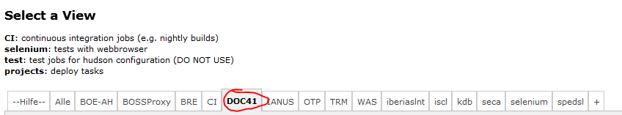
* Click the green icon at the right end of the line labeled “DOC41-Servercontrol”:  
  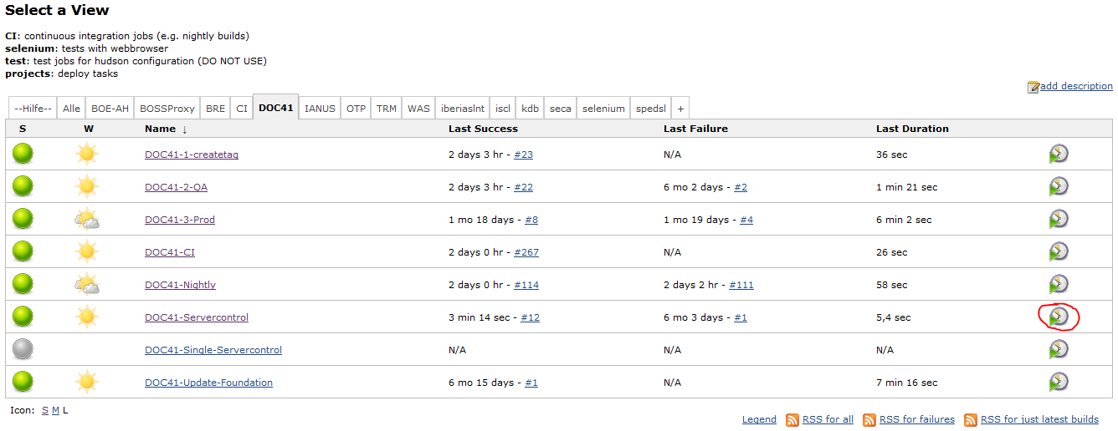
* Enter the following parameters in the dialog  
  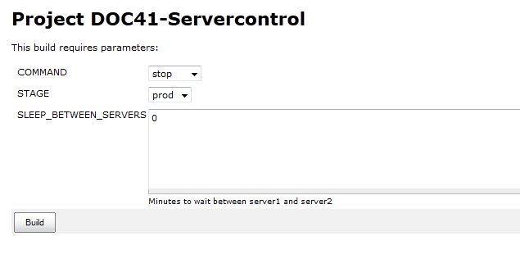
  + Select a command
    - stop for shut-down
    - start for start-up
    - restart for recovery
  + Select the stage
    - dev: development server connected to D2R
    - qa: test system connected to Q2R
    - prod: production system connected to P2R
  + Sleep_between_servers:
    - for start-up and shut-down keep the default value 0
    - for recovery enter 5
* Click Build
* In the Build History on the left side a new build with a progress bar is shown  
  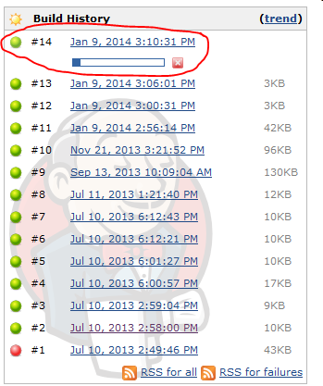
* Wait until the progress bar disappears. If the dot on the left side is now green, the start-up, shut-down or recovery was successful  
  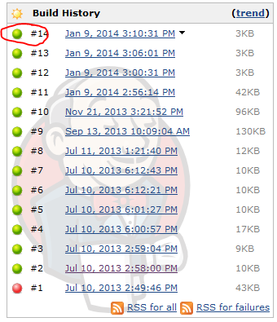

# User management

## Overview

This screen shows an overview of all users.

The users can be filtered by entering values in the header filter fields.  
The users can be sorted by clicking on the in the header fields.

The first icon indicates the status of the user: green for active, red for inactive. This status can be toggled by clicking the red/green icon in the last column. The icon in the second to last column opens the edit dialog.

There are two buttons to create an internal or external user.

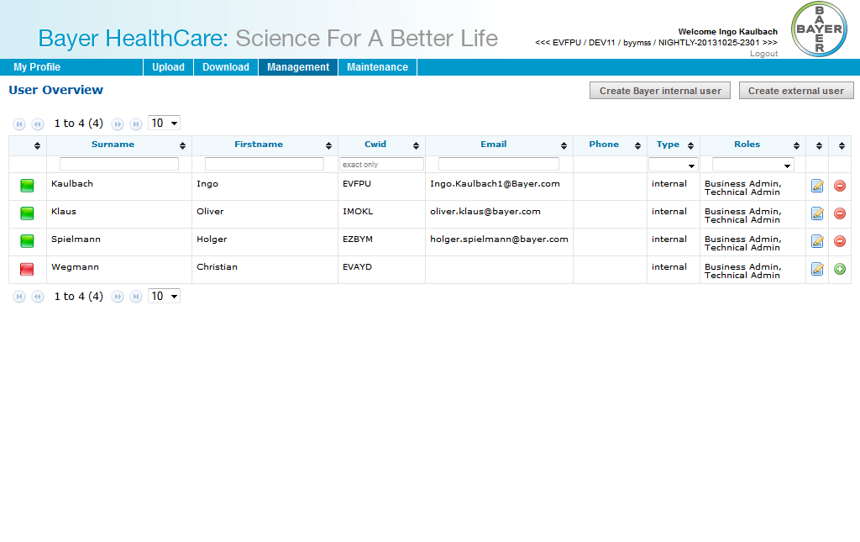

## Create Bayer internal user

This screen is used for importing internal (=Bayer) users into the system. After a CWID is inserted and “Create Bayer internal user” is clicked, the Import Screen will be shown.

Time zone, language and status of the user have to be set. Only active users can log into Doc41WebUI.

An internal user can have following roles:

* Business Admin
* Technical Admin
* *Observer*

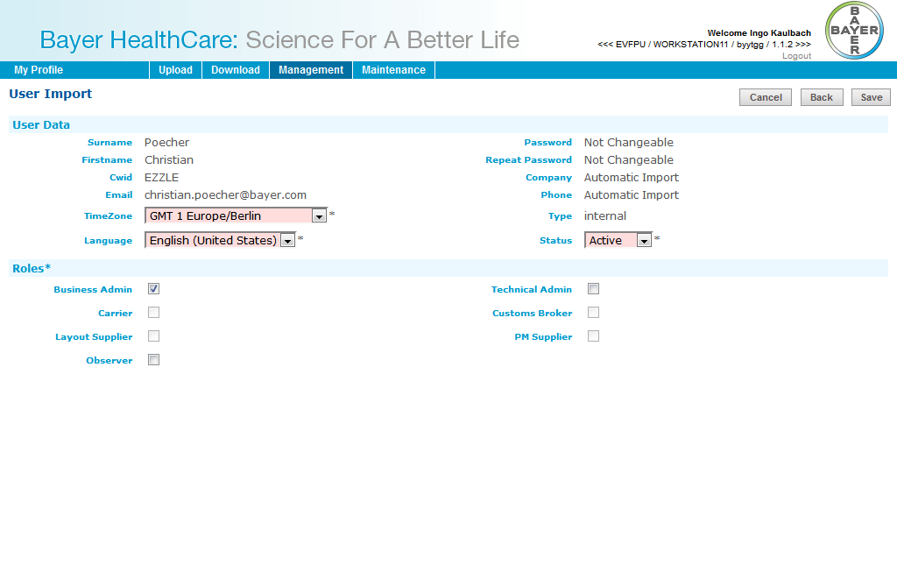

Cancel will go back to user overview.  
Back will go back to enter another CWID.  
Save will create the user.

## Create external user

This screen is used for creating external users into the system.   
For external users First-, Surname, Email-Address and Password must be entered.

Time zone, language and status of the user have to be set. Only active users can log into Doc41WebUI.

An external user can have following roles:

* Carrier
* Customs Broker
* Material Supplier
* Product Supplier
* Viewer Country
* Viewer Customer
* Layout Supplier
* PM Supplier
* *Observer*

An external user can have Partner Numbers, Countries and Plants.  
Partner Numbers are only numbers (no letters etc.). After click on “Add”-button the partner will be searched in SAP and added to list, if found.  
Countries can be added from a list.  
Plants can be added as text. A Plant must only have numbers and upper case letters and a maximum length of 4.

Cancel will go back to user overview.  
Save will create the user.

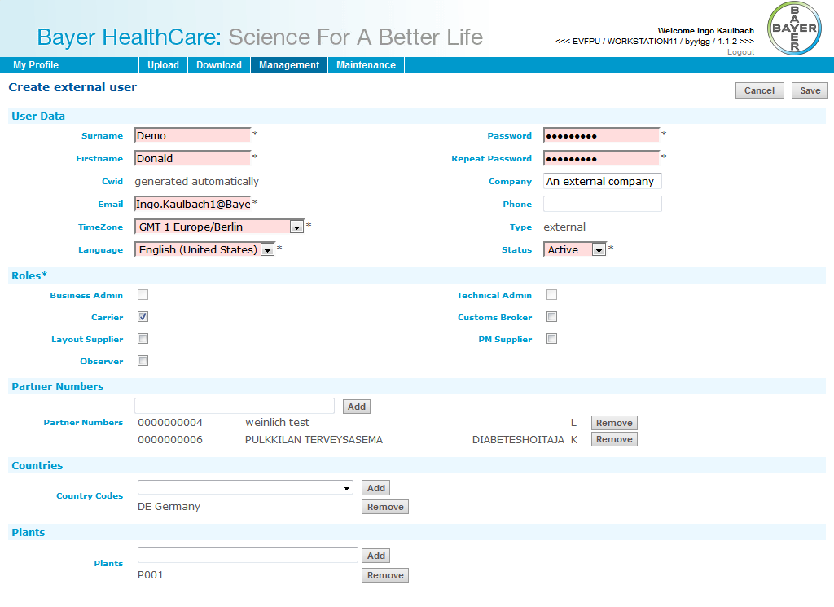

## Edit User

This dialog is used for existing internal/external users. It looks like the User Import or Create external user dialog.

### Internal

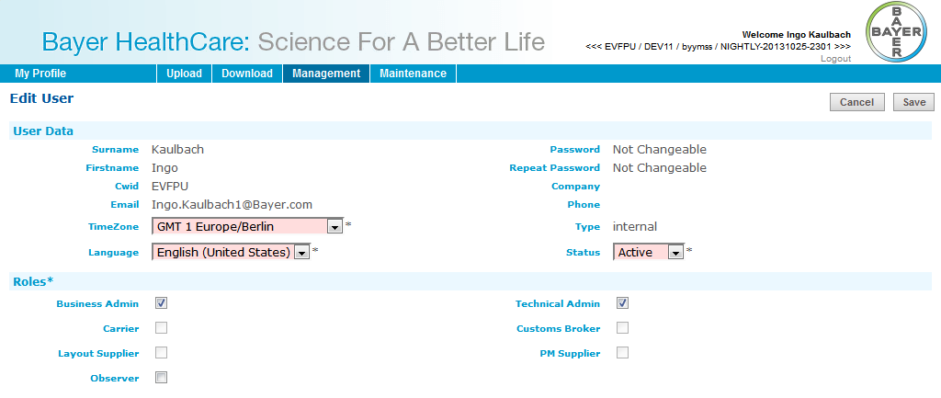

### External

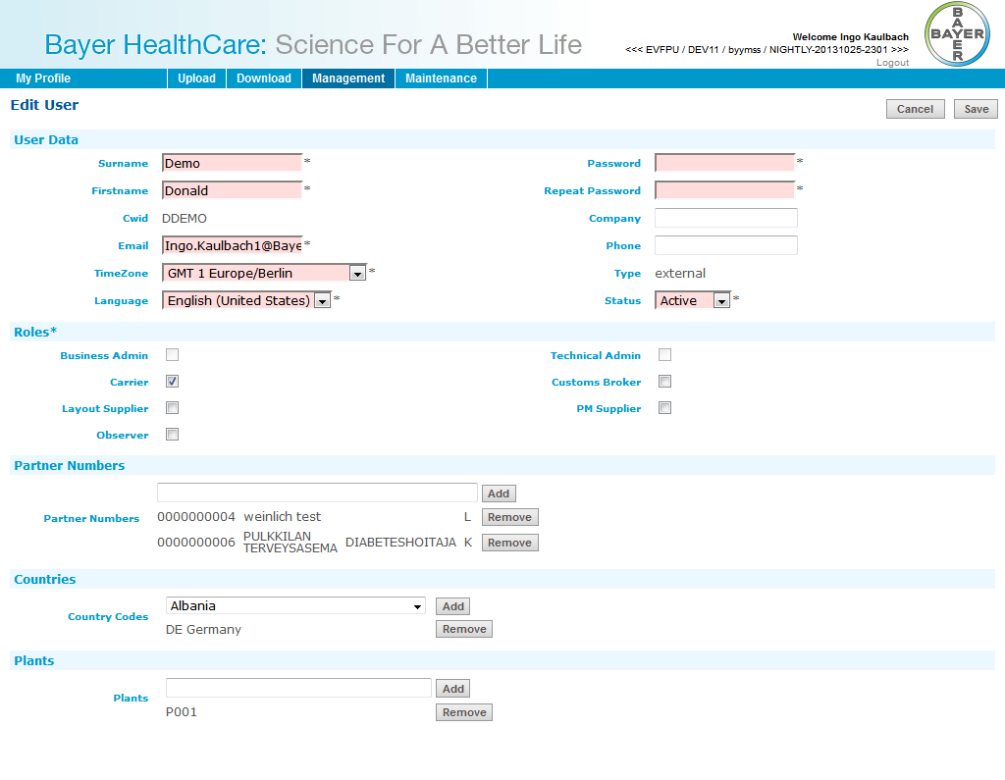

# Administration of Master Data

WebUI has a copy of the partner data (vendors and customers) from P2R. This copy is updated automatically.

P2R exports a CSV file (D41_PARTNER.txt) in the following format:

* Columns are divided by a semicolon ;
* Strings are surrounded by “
* “ inside the Strings are escaped by doubling them like “”
* The columns are: Partnernummer, Name1, Name2, Street, Postal Code, City, Country, Partner Type (L for vendor, K for customer), Deletion Flag, Change Date

Example:

PARTNER_NUMBER;NAME1;NAME2;STRAS;PLZ;CITY;COUNTRY;PARTNER_TYPE;DELETION_FLAG;CHANGEDATE

"0000000001";"Akmler";"";"";"";"";"FR";"L";"";"20080815"

"0000000001";"TEST AKM 2009";"";"";"";"1";"DE";"K";"";"20090213"

"0000000002";"tes wizard";"";"Kaiser-Wilhelm-Allee 60";"51373";"Leverkusen";"DE";"L";"";"20061103"

"0000000002";"Bayer Business Services GMBH2.";"";"Hauptstr. 20";"51373";"Leverkusen";"DE";"K";"";"20070606"

"0000000003";"Sunflag (Tanzania) Ltd";"Plot # 33 Themi Industrial Area";"PO Box 3123";"";"Arusha";"TZ";"K";"";"20070130"

"0000000004";"weinlich test";"";"Homarstr. 10";"51107";"Köln";"DE";"L";"";"20130312"

"0000000004";"TEST AKM 2009";"";"";"60000";"Frankfurt/M";"DE";"K";"";"20090211"

"0000000006";"PULKKILAN TERVEYSASEMA";"DIABETESHOITAJA";"SAVONOJANTIE 2";"92600";"PULKKILA";"FI";"K";"";"20130806"

"0000000008";"Test 2520000";"";"";"";"";"DE";"L";"";"20090310"

"0000000010";"test1241";"";"";"12345";"Test";"DE";"L";"";"20020830"

This file is then read by a chain process and imported into the WebUI database. This chain process will run at yet to be defined fixed times.

The chain process can also be called manually:

. /home/mxgbi/Chain-DOC41WEB.config && ${CHAIN_BIN_PRJ}/cronDOC41WEB-1.sh &

# System Management and Maintenance

## Database reorganization

The administration and reorganization of the database is in the responsibility of BDC-DATABASE.

## Export Files for Backup

The database is backed up by BDC. So, there are no export files generated by WebUI for backup.

## Archiving

WebUI only contains internal data like the users. The main data like the documents or their attributes is kept in external systems (ArchiveBroker, P2R). Therefore database of WebUI is small and no archiving is necessary.

## Monitoring

The availability of WebUI is monitored by the external System Nagios under the responsibility of Cap Gemini. If WebUI is no longer reachable, the supporters are informed automatically by email.

Nagios also has a web interface <https://by-ebcmon.bayer-ag.com/nagios/>  
Current problems:  
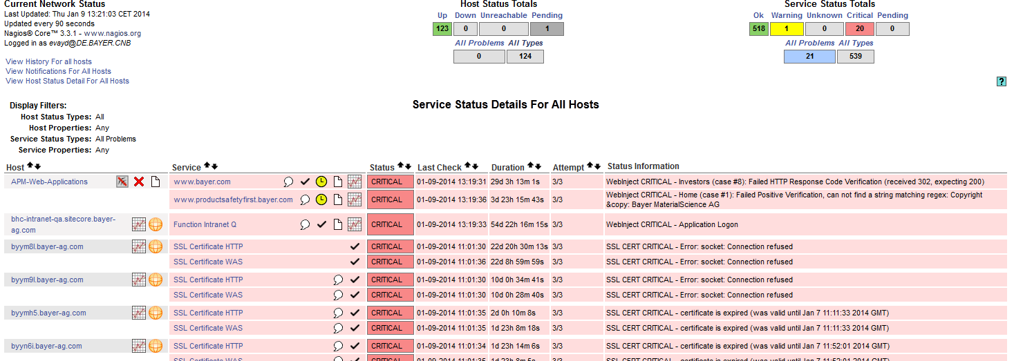

Availability reports about the compliance with the SLA:

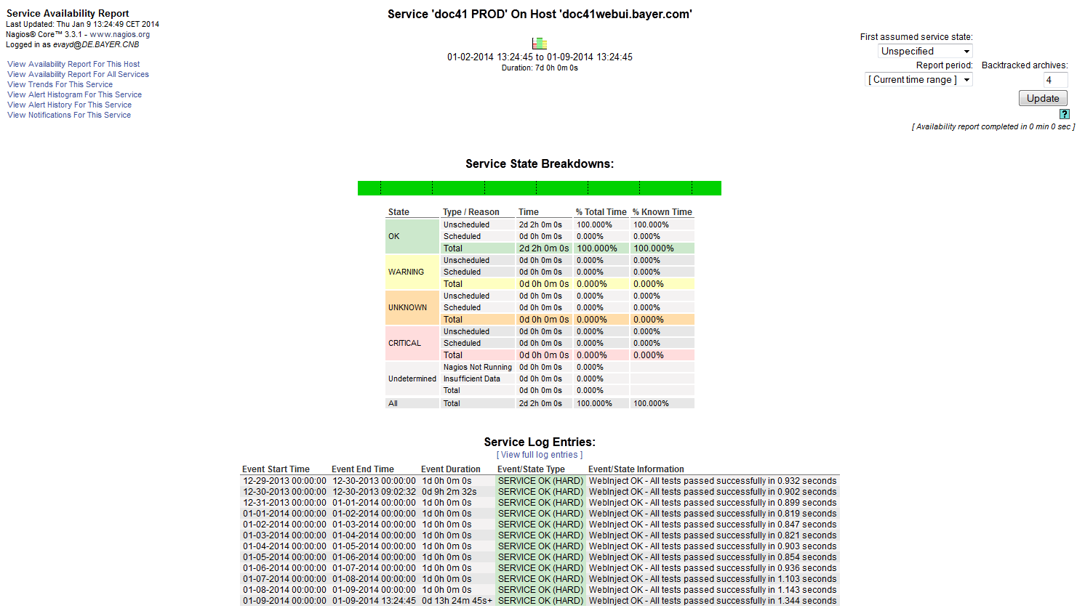

## Maintenance

Maintenance is divided into 3 areas: Operating System (Linux), Application Server (Tomcat), the WebUI-Application itself.

The Operating System is maintained by BDC Linux Support (BDC-Linux-Support@bayer.com).

The Application Server is maintained by APM-Webplattforms (apm-webplattforms@bayer.com).

If a problem occurs in the WebUI-Application the user contacts the hotline. The hotline will then create a ticket with this problem. In the future it will also be possible to send an email to a collective address, where the ticket will be created automatically.

This incident ticket is then assigned to the responsible supporter. After the problem is solved, the supporter closes the ticket and the user is informed.